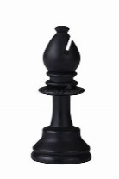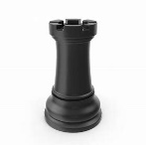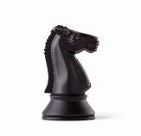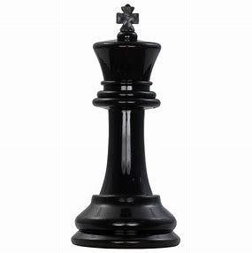
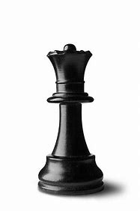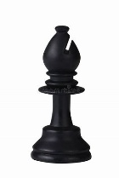
OFF THE GRID CHESSPIECE    HALL  HALIFAX
Halifax . Every Thursday 6pm to 9pm outside The Wine Barrel Café
"Off the Grid Chess" is the name we've given to our specific project of promoting chess at the Piece Hall in Halifax, but could equally be applied to a much wider, perhaps almost worldwide post Covid phenomenon as a plethora of new players are motivated to play within in a more sociable set up than the internet, or even a chess club. Our default way of playing tends to be by no means uncompetitive, yet is more exploratory and relaxed than purely competitive. We believe that a game only works as a game if the result has no lasting consequence. After all, even chess is not a contest in the same way that a duel was! Play theorist Bernard DeKoven, coined the term 'tournamentality' for the state of mind in which accumulated game results gain more significance than the game one is playing right now, and, of course, a degree of this is inevitable whenever a game is played in a 'sportized' way. (read more)
So, for club players we are 'off grid' in the sense that games are neither rated nor contributive to the exploits of a team - and freedom to experiment gets released by that. This also promotes enjoyably including newer players since experimentality can make games more interesting while facilitating learning. For example, watching out for questionable but challenging moves engages one player while the 'learner' gains by attempting to solve the problems that ensue. This way of playing can promote familiarity with tactical motifs much better than bedazzling new players with a list of examples.. Also better sight of the board and awareness of strategic principles can be facilitated by revisiting these moments in the context of the whole game.

Sociability tends to thrive in this atmosphere too. Our situation- playing outside in a cafe set in the arcaded rim of the Piece Hall- is not, unlike playing at a club or online- hidden from public view and this interface with the public benefits both chess and the inspiring vibe offered by the venue we've chosen. So... give us a buzz or just turn up...

6..00 pm at The Wine Barrel near the Westgate entrance to the Piece Hall every Thursday.
Phone:
Andrew Perkis 07733 166183
Bob Gaunt 07413 404252
Dave College 07768 474630
for more information.

